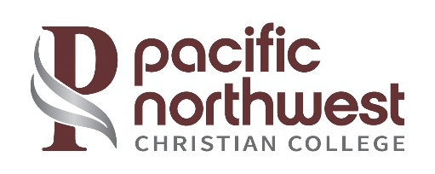

Pacific Northwest Christian College Retention Rates*

Program | 2023-2024 | 2022-2023 | 2021-2022 | 3 Yr. Average
Associate | 37% | 50% | 50% | 46%
*Retention rates for an associate’s program are fall-to-fall based on first-time, full-time status

Pacific Northwest Christian College Graduation Rates**

Program | 2020 Cohort^ | 2019 Cohort | 2018 Cohort | 3 Yr. Average
Associate | 18% | 51% | 61% | 43%
** The completion/graduation rates for associate degrees are measured at 150% of the expected completion time (the associate degree rate is three years from the first enrollment).
^2020 Cohort impacted by COVID-19

Pacific Northwest Christian College Transfer-Out Rates***

Program | 2020 Cohort^ | 2019 Cohort | 2018 Cohort | 3 Yr. Average
Associate | 18% | 9% | 0% | 9%
*** These students transfer before completing their associate’s program at PNWCC within three years of enrollment. The transfer-out rates for associate degrees are measured at 150% of the expected time for completion (the associate degree rate is within three years from the first enrollment).
^2020 Cohort impacted by COVID-19

